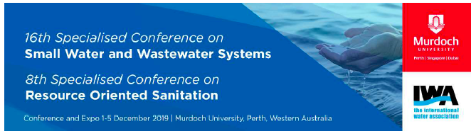
SPECIAL STREAM ABORIGINAL & TORRES STRAIT ISLANDER
ENVIRONMENTAL HEALTH & WATER
REGISTRATION
Name: ……………………………………………………………………………………………………………………………….

Address …………………………………………………………………………………………………………

………………………………………………………………………………………………………..

Telephone/mobile: …………………………………………………………………………………………………………..

Email: ……………………………………………………………………………………………………………………………….

Community & Language group: …………………………………………………………………………………………

I am an Aboriginal/Torres Strait Islander person and wish to register for the SWWS2019 conference from 1-5 December 2019 at Murdoch University. I understand the registration includes attendance at the special stream on Aboriginal Health and Water.

- I require airfare or mileage allowance if driving and will invoice the conference for payment with an account number. YES/NO

- I require accommodation from……….xx December and will depart on……. xx December [maximum 5 days]

No of days YES/NO

- I am a student YES / NO

- I would like to:

Attend the workshop on Sunday 1 December: Workshop 1-YES/NO Workshop 2 - YES/NO

attend the Welcome Reception at the University on Sunday, 1st December 5.00pm YES/NO

go on one of the three free field visits on the afternoon of Tuesday, 3rd Dec. YES/NO 1, 2,3

attend the closing ceremony at 6pm on Wednesday, 4th Dec. YES/NO

attend the conference dinner on Monday 2nd , evening at a cost of $55 YES/NO

go on one of the two technical tours on Thursday, 5 Dec. cost of $110 YES/NO 1, 2

(for full details of Field visits and Technical tours please see www.swws2019.com)

Signature/Name which ever convenient ……………………………………………………………………………………………

Please email to Dr Kuruvilla Mathew, Murdoch University, conference co-manager.
email: K.Mathew@murdoch.edu.au mobile: 0406 644 947

Note: Subsidies for Travel, Accommodation and the Conference fees are available. Special consideration will be given to organizations and individuals where funding sources are limited. We acknowledge the financial support of the Federal Minister for Indigenous Australians and the Commonwealth Dept. of Health.

