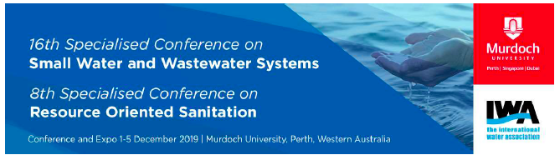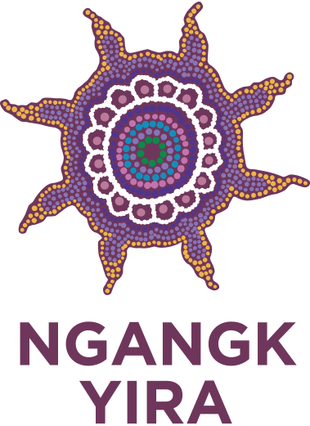

SPECIAL STREAM ABORIGINAL & TORRES STRAIT ISLANDER
ENVIRONMENTAL HEALTH & WATER

Expression of Interest Form

Name: ……………………………………………………………………………………………………………………………………………………………………

Telephone: ……………………………………………………………………………………………………………………………………………………………

Email: ……………………………………………………………………………………………………………………………………………………….……………

I am an Aboriginal/Torres Strait Islander person. I wish to register for the SWWS2019 conference which includes a special stream on water supply and disposal issues that directly affect Aboriginal & Torres Strait Islander environmental health, 1-5 December 2019 at Murdoch University.

Return this form before 1st November.

Signature: ……………………………………………………………………………………………………………………………………………………………

For further information please refer to www.swws2019.com.

Submit your Expression of Interest for the Special Stream, ‘Aboriginal and Environmental Health’ to:

Dr Kuruvilla Mathew, Research Fellow, Murdoch University, conference co-manager.
email: K.Mathew@murdoch.edu.au mobile: 0406 644 947

OR
Dr David Goodfield, Adjunct Lecturer, Murdoch University, conference co-manager. D.Goodfield@murdoch.edu.au mobile: 0437 282 209

Note: Subsidies for Travel, Accommodation and the Conference fees are available. Special consideration will be given to organizations and individuals where funding sources are limited. We acknowledge the financial support of the Federal Minister for Indigenous Australians.

CONFERENCE TOPICS

- Water Resources
- Water quality management
- Governance, policy and regulation
- Wastewater treatment
- Wastewater collection and disposal
- Wastewater treatment & reuse
- Landscape and water management
SPECIAL STREAM TOPICS

- Water Quality in our Communities
- Sanitation
- Social Impact and Quality of Life
- Innovative Solutions
- Codesign and Policy Change
- Governance

Aboriginal & Torres Strait Islander Environmental Health and Water will be a special stream in the conference on Small Water and Wastewater Systems to be held at Murdoch University, 1-5 December 2019. This gives an opportunity for International delegates to understand the situation, technologies and facilities in Aboriginal & Torres Strait Islander communities in Australia. We extend a warm welcome to all Aboriginal & Torres Strait Island people and international delegates for this special gathering and exchange of ideas.

OBJECTIVE OF CONFERENCE

Environmental health and water management is very important for healthy thriving communities. Environmental health and water aspects in the Aboriginal & Torres Strait Islander communities needs special attention and policies for improvement. Papers in small water and wastewater systems will be presented in the conference, along with a special stream that will consider the improvements necessary in Aboriginal & Torres Strait Islander environmental health.

VENUE

The conference will be hosted by Murdoch University situated on Wadjuk, Noongar Country, in the southern suburbs of Perth, Western Australia, only 12 minutes by train from the centre of the city and a short bus ride from the popular tourist destination of Fremantle. The University has excellent conference, exhibition and catering facilities, and accommodation which enables delegates to maximize their time during the conference.

CONFERENCE SPECIAL FEATURES

The conference opens on Sunday, 1 December 2019 at Murdoch University and will include the following:
- A welcome reception in the evening headed by an Aboriginal cultural event.
- The official conference inauguration, Monday, 2nd Dec. will feature a Welcome to Country and
inauguration by the WA State Minister for Water.
- The conference dinner cruise on the Swan River will be held in the evening of Monday 2nd Dec.
(there are limited seats so book early!)
- There will be a choice from three field visits in the afternoon of Tuesday, 3rd Dec.
- A ‘happy hour’ will be held at the University after the field visits.
- The closing ceremony will be held in the evening of Wednesday, 4th Dec. at the University.
- Technical tours to peri-urban and rural areas will be available on Thursday, 5th Dec. by separate payment.
- WiFi will be available on campus.
- Light refreshments and lunches will be available each day.

INVITED SPEAKERS (in the Aboriginal Stream)

- Hon. Ken Wyatt, AM MP, Federal Minister for Indigenous Australians.
- Professor Rhonda Marriott, Director, Ngangk Yira: Murdoch University.
- Mara West, Coordinator, Kulunga Aboriginal Research Development Unit (KARDU), Telethon Kids Institute.
- & other key experts to be confirmed

Indigenous Advisory Committee:

- Prof Rhonda Marriott, Director, Ngangk Yira: Murdoch University Research Centre for Aboriginal Health and Social Equity.
- Jade Maddox, Ngangk Yira Research Coordinator & Cultural Co-lead.
- Mara West, Mara West, Coordinator, KARDU Unit, Telethon Kids Institute.
- Vanessa Kickett, Water Corporation.
- Sharynne Hamilton, Murdoch University.
- & other local and national people to be confirmed.

Supporting Organizations

- Commonwealth of Australia Minister for Indigenous Australians.

- Government of Western Australia:
  - Department of Communities
  - Department of Water
  - Department of Health
- Murdoch University
- Ngangk Yira, Aboriginal Health Research Centre.
- International Water Association
- Australian Water Association
- Environmental Technology Centre & Kulbardi Aboriginal Centre, Murdoch University.
- Water Corporation of Western Australia.
- Syrinx Environmental
- Moerk Water
- Amiad Water Systems
- Athena Water Services
- Perth Convention Bureau
- International Water Centre
- Environmental Health Australia
- UTS| Institute for Sustainable Futures
- Urbaqua| Land & Water Solutions
- ICEWaRM| International Centre of Excellence

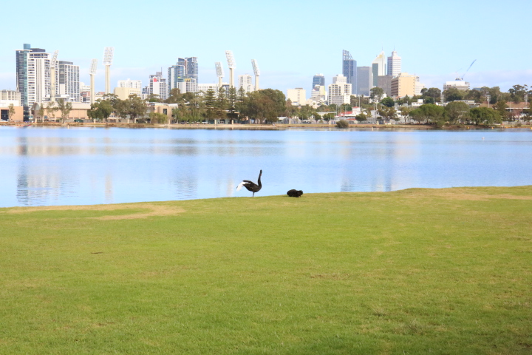
Sponsors Supporters

