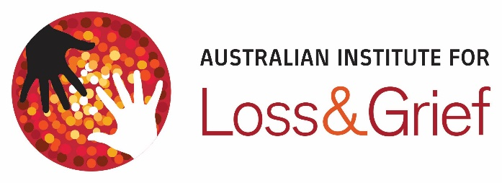

Aboriginal Loss & Grief Averting Mental Health Challenges

30 Nov to 2 Dec 2020

$660.00 +GST
Workshop Registration Form
Morning and afternoon tea provided. BYO Lunch, Course fee includes all materials

PARTICIPANT DETAILS

Full Name: Click or tap here to enter text.
Address: Click or tap here to enter text.
Telephone numbers: Click or tap here to enter text.
Email: Click or tap here to enter text.

FOR INVOICING PURPOSES (if different from above):

Contact Persons Details: Click or tap here to enter text.
Name: Click or tap here to enter text.
Address: Click or tap here to enter text.
Phone: Click or tap here to enter text.
Email for Invoicing: Click or tap here to enter text.

PLEASE COMPLETE THE FORM AND EMAIL TO programs@lossandgrief.com.au
2/107 Military Road
Semaphore South
South Australia 2019
T 08 8341 5557
E programs@lossandgrief.com.au
W lossandgrief.com.au
ACN 117 236 736
We will contact you to confirm your registration. Fees are payable on receipt of invoice and are non-refundable. Workshop registration can be transferred to another person within your organization. If a workshop is cancelled by the Australian Institute for Loss and Grief, a full refund of registration costs only will be refunded.

