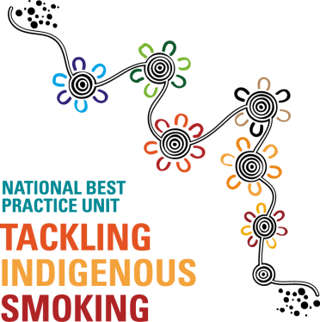
Registration Form
Tackling Indigenous Smoking (TIS) National Workshop
Thursday 3rd May 2017
9.00am – 5.00pm

Workshop dinner: 6:00pm – 10:00pm

Venue: Hilton Hotel
233 Victoria Square
ADELAIDE SA 5000

This workshop has been designed to: Showcase the successes of the TIS Program and strategize the challenges to effectively deliver, monitor and report on TIS activities.

Please register your interest in attendance at this workshop, by completing the following details:
Name of organisation: ___________________________________________________________________
- Name: ______________________________________ Role: __________________________________

- Name: ______________________________________ Role: __________________________________
Contact name: __________________________________________________________________________
Phone number: _________________________________ Email: _________________________________
Will you both be attending the workshop dinner?: Yes No
Please note any dietary requirements: _______________________________________________________

Completed Registration Forms are to be returned to info@tacklingindigenoussmoking.com.au
by
COB Monday 9th April 2018
For more information, please do not hesitate to contact the NBPU TIS on 1800 282 624
Thank you

