Department of Health
Registered Training Organisation
National Provider Number 0385

Healthy Smiles
Course completion meets the performance and knowledge evidence required for
the nationally accredited HLTOHC006 apply fluoride varnish. This stand alone unit forms
part of the HLT Health Training Package.

The program has been designed to equip Registered Health Practitioners (primarily registered nurses and Aboriginal Health Practitioners (AHPs) with skills necessary to apply fluoride varnish and to complete all components of the Well Child Health Check, part of the Healthy Under 5 Kids Program – Partnering Families (HU5K- PF). It provides some oral health background information, knowledge about early childhood decay as well as prevention and management
Target Audience
- Registered Health Practitioners- Nurses, Aboriginal and Torres Strait Islander Health Practitioners
- Outreach, Child and Family Health Nurses.

Training is funded by the Northern Territory Remote Aboriginal Investment (NTRAI).

Contents
- Oral health and oral diseases including Early Childhood Caries (ECC)
- Links to chronic health conditions
- Lift the Lip oral health checks
- Risk and referral guidelines
- Anticipatory guidance and oral health promotion
- Fluoride and application of fluoride varnish.
Training
Registered Health Practitioners can access the online theory modules training through the MyLearning link: https://mylearning.nt.gov.au/my/
After logging into the site, please enrol in: Healthy Smiles Online – Oral Health & Fluoride Varnish Training 2018.
- Self-paced online theory modules and workbook assessment- Approx. 1 full day
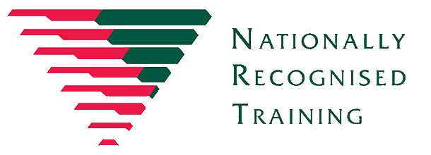
- Face to face practical training and assessment session by a trainer/assessor who holds a Certificate IV in Training Assessment and registered as a trainer with the Northern Territory Department of Health to achieve the competency- Approx. ½ day.

Language, literacy and numeracy requirements
An appropriate level of language, literacy and numeracy is required to complete this Certificate IV unit.
It is recognised that health professionals accessing this training will have previously acquired a professional qualification at a minimum of this level for professional registration. Course applicants may identify and request specific support needs as part of the application process.
Recognition of prior leaning (RPL)
RPL is offered to applicants, to find out more information please contact the Oral Health Training Coordinator (details can be found below).
Assessment methods and outcomes:
- Written/online workbook and practical demonstration assessments.
- Completion of HLTOHC006 will allow participants to:
  - Return to their workplace and applying fluoride varnish to the teeth of children aged between 18 months and four years of age, meeting NT jurisdictional, legislative and regulatory requirements.
  - Provide informed and targeted oral health guidance to parents/carers.
  - Document, recall and refer appropriately in a child’s health care plan.
For more information please contact the Oral Health Training Coordinator:
Phone: 8922 6416
Email: oralhealthpromotion.ths@nt.gov.au

