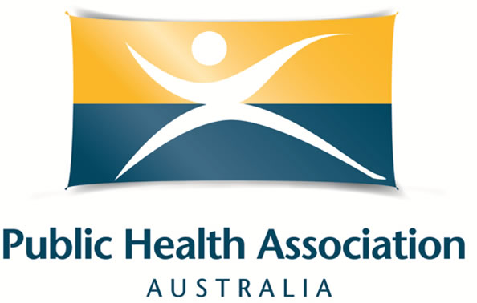

Aboriginal and/or Torres Strait Islander Public Health Student/Trainee Scholarship Criteria and Application Form for the
2019 Public Health Prevention Conference OR the 2019 Australian Public Health Conference

With the aim of building the advocacy skills and capacity of our members, PHAA (WA Branch) is pleased to offer a scholarship to attend either the Public Health Prevention Conference in Melbourne in June 2019 or the Australian Public Health Conference in Adelaide in September 2019 (the applicant can select either conference). Applicants must be from an Aboriginal and/or Torres Strait Islander background and have a strong interest in public health. Applicants do not need to be a PHAA member to be eligible.

Applications Close: Friday March 29 2019
Applications received after this date will not be considered.

The total dollar value of the scholarship is $2250 to cover the cost of registration and funding towards accommodation and airfare expenses. PHAA will purchase the registration, accommodation and airfare on your behalf. A 12-month membership to PHAA will be provided to the successful applicant.

Eligibility Criteria
Applicants must be:
- living and working in Western Australia.
- Aboriginal and/or Torres Strait Islander.
- available to attend the conference if their application is successful.
- be a current student or trainee in a relevant public health field.
- have no access to financial support through your employment or a full scholarship to attend the conference.
How to apply
- Please complete the form provided in writing or by video, ensuring you answer all questions.
- Email completed form or video along to phaawabranch@gmail.com by Friday March 29 2019.

Assessment of applications
- A selection panel from the PHAA National Office and WA Branch Strategic Advisory Committee will assess all applications received.
- Applicants will be notified of the outcome by Wednesday April 10 2019.

Eligible student or trainees
- Eligible applicants include:
  - Students (third year or fulltime equivalent) in a relevant undergraduate public health degree
  - Current Higher Degree Research (Masters or PhD) students in public health
  - Trainees in relevant public health fields e.g. WA Aboriginal Traineeship Program, Fellowship of the Australian Faculty of Public Health Medicine, Aboriginal and Torres Strait Islander Health Worker training, Aboriginal Health Training

If you are unsure of your eligibility, please contact phaawabranch@gmail.com to clarify.

You do not have to be a current PHAA member to apply.

Scholarship conditions
- Successful applicants are asked to write a 500-word article or video to highlight the most interesting points of the Conference and provide a photo to be included in the Intouch in WA newsletter and to feature on the PHAA website. PHAA WA will provide assistance with writing if requested.
- PHAA will purchase registration, airfares and accommodation on your behalf, and will communicate with you to ensure the flights and accommodation are suitable
- Only airfares and accommodation expenses (directly associated with the conference) will be covered (i.e. not taxis, transfers, subsistence, etc.).

Additional information
- The cost of conference attendance may be greater than the amount of the award, and scholarship recipients are expected to independently fund any shortfall.
- The scholarship will fund only the base level registration for conference attendance. Scholarship recipients wishing to attend other workshops or extra events may do so by paying for this out of their own funds. To do this, contact the conference secretariat at events@phaa.net.au
- The National Office will register you for the conference on your behalf and will send you an email confirmation once processed.
- The scholarship recipient is able to choose if they wish to attend the Public Health Prevention Conference 2019 or the Australian Public Health Conference 2019. They must nominate their preference on their application form. For more details about either conference, please visit the PHAA website.

Selection process
- One awardee will be decided based on:
- Anticipated benefits of attending the conference
- Contribution to public health through public health practice, voluntary work, community-based activities, research or PHAA committees or events

Preference will be given to applicants who have not previously been awarded a PHAA conference travel scholarship.

Application process
Please email a completed Application Form (see below) or a video (up to five minutes) to the PHAA WA Branch (phaawabranch@gmail.com) on or before COB Friday March 29 2019.

If you have questions on the application process, please contact us at the above email address.

Scholarship Application Form
Australian Public Health Conference 2019

Applicant details

Name
Phone
Email
Address
Current degree/training program

Or
Institute / Organisation

Please tick to confirm the following statements to demonstrate your eligibility.
I am a resident of Western Australia.
I am currently a student or trainee in a relevant public health field.
I do not have access to financial support through employment or other scholarships to attend the conference.
I am Aboriginal and/or Torres Strait Islander.

*Maximum of 300 words per question

If you are unsure of any of the question, please email phaawabranch@gmail.com for clarification

Please describe your current work and/or study experience in public health.

Please describe any other relevant experience in public health (i.e. volunteering, previous employment, etc.).

Please outline how your attendance at a PHAA Conference will benefit your studies and your future work.

Please nominate if you wish to attend the Public Health Prevention Conference (June 2019 in Melbourne) or the Australian Public Health Conference (September 2019 in Adelaide), and why.

Declaration by scholarship applicant
I declare that the information given on this application form is accurate and complete.

Scholarship applicant

Name: ___________________ Signature: ______________________ Date: ____________

