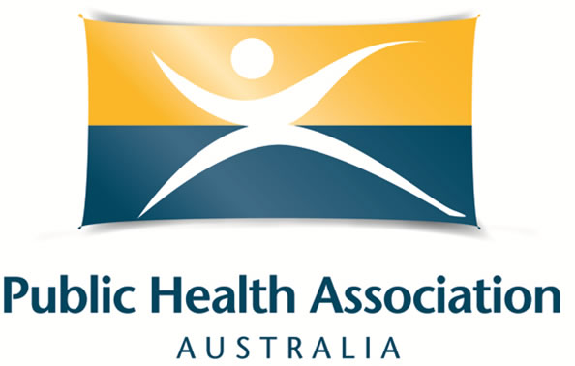

Scholarship Criteria and Application Form for the
2019 Public Health Prevention Conference OR the 2019 Australian Public Health Conference
With the aim of building the skills and capacity of our members, PHAA (WA Branch) is pleased to offer a scholarship to attend either the Public Health Prevention Conference in Melbourne in June 2019 or the Australian Public Health Conference in Adelaide in September 2019 (the applicant can select either conference).

Applications Close: Friday March 29 2019
Applications received after this date will not be considered.

The total dollar value of each scholarship is $2250 to cover the cost of registration and funding towards accommodation and airfare expenses. PHAA will purchase the registration, accommodation and airfare on your behalf. The scholarship offer applies to individual applicants only; organisations are ineligible.

Eligibility Criteria
Applicants must be:
- a current individual member of the Public Health Association Australia.
- living and working in Western Australia.
- able to demonstrate strong interest and commitment to public health.
- available to attend the conference if their application is successful.
- have no access to financial support through your employment or a full scholarship to attend the conference.

How to apply
- Please complete the form provided in writing or by video, ensuring you answer all questions.
- Email completed form or video along with a brief CV to phaawabranch@gmail.com by

Assessment of applications
- A selection panel from the PHAA National Office and WA Branch Strategic Advisory Committee will assess all applications received.
- Applicants will be notified of the outcome by Wednesday April 10 2019.

Scholarship conditions
- Successful applicants are asked to write a 500-word article or video to highlight the most interesting points of the Conference and provide a photo to be included in the Intouch in WA newsletter and to feature on the PHAA website. PHAA WA will provide assistance with writing if requested.
- PHAA will purchase registration, airfares and accommodation on your behalf, and will communicate with you to ensure the flights and accommodation are suitable
- Only airfares and accommodation expenses (directly associated with the conference) will be covered (i.e. not taxis, transfers, subsistence, etc.).

Additional information
- The cost of conference attendance may be greater than the amount of the award, and scholarship recipients are expected to independently fund any shortfall.
- The scholarship will fund only the base level registration for conference attendance. Scholarship recipients wishing to attend other workshops or extra events may do so by paying for this out of their own funds. To do this, contact the conference secretariat at events@phaa.net.au
- The National Office will register you for the conference on your behalf and will send you an email confirmation once processed.
- The scholarship recipient is able to choose if they wish to attend the Public Health Prevention Conference 2019 or the Australian Public Health Conference 2019. They must nominate their preference on their application form. For more details about either conference, please visit the PHAA website.

Selection process

- One awardee will be decided based on:
- Anticipated benefits of attending the conference
- Contribution to public health through public health practice, voluntary work, community-based activities, research or PHAA committees or events

A planned/submitted/accepted conference abstract is desirable but not essential.

Preference will be given to applicants who have not previously been awarded a PHAA conference travel scholarship.

Application process
Please email a completed Application Form ( see below) or a video (up to five minutes) to the PHAA WA Branch (phaawabranch@gmail.com) on or before COB Friday March 29 2019.

If you have questions on the application process, please contact us at the above email address.

General Scholarship Application Form
2019

Applicant details

Name
Length of PHAA membership (years)
Position
Organisation
Phone
Email

Please tick to confirm the following statements to demonstrate your eligibility.
I am a resident of Western Australia.
I am currently an individual PHAA member.
I do not have access to financial support through employment or a scholarship to attend the conference.
I have attached a brief CV to my application.

*Maximum of 300 words per question

If you are unsure of any of the questions, please email phaawabranch@gmail.com for clarification

Please describe your current work and/or study experience in public health.

Please describe any other relevant experience in public health (i.e. volunteering, previous employment, etc.).

Please outline how your attendance at a PHAA Conference will benefit your studies and your future work.

If applicable, please provide details on planned, submitted or accepted abstracts below.

Please nominate if you wish to attend the Public Health Prevention Conference (June 2019 in Melbourne) or the Australian Public Health Conference (September 2019 in Adelaide), and why.

Declaration by scholarship applicant
I declare that the information given on this application form is accurate and complete.

Scholarship applicant

Name: ___________________ Signature: ______________________ Date: ____________

