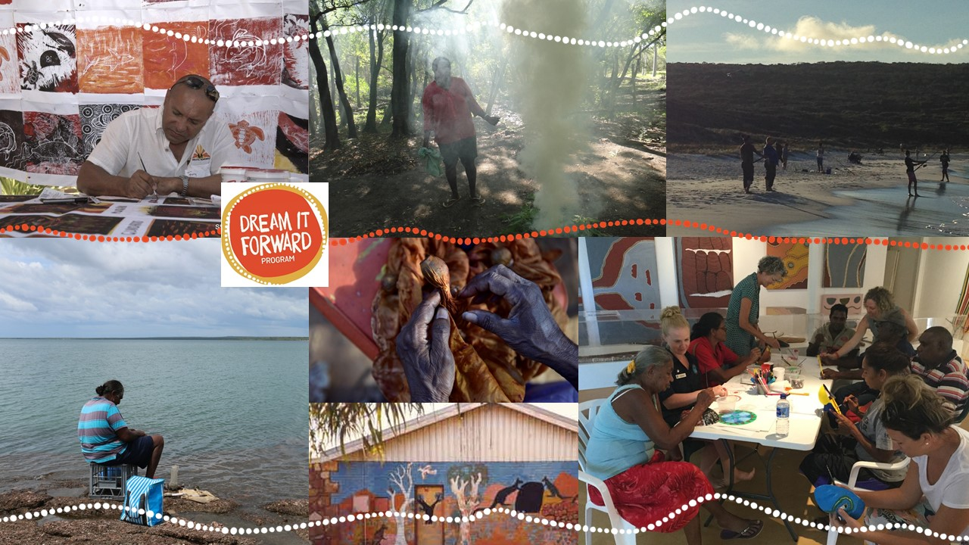

ConnectGroups announces the next round of Dream it Forward – the small grants program focusing on the social and emotional wellbeing of Aboriginal and Torres Strait Islander people, families, and communities in Western Australia.
Dream it Forward projects are: based on needs identified by community, led by community, for community, and strengthens cultural identity.
The Guidelines and Application Form for the 2019 funding round can be accessed by clicking below:
Dream it Forward Guidelines and Application Form
Applications due by: Thursday 27th June 2019 for projects up to $7,000.
For clarification, information and support with your ideas for submission to this funding round, please contact:
Christine Hendricks
Project Coordinator
christine@connectgroups.org.au
Phone: 08 9364 6909

Karen Silverthorne
Community Engagement Officer
karen@connectgroups.org.au
Phone: 08 9364 69

