Sponsorship Program 2016–2018

Guidelines for applicants

Introduction

The Great Barrier Reef Marine Park Authority (GBRMPA) has a Sea Country Partnerships Sponsorship Program which can assist Great Barrier Reef Traditional Owners to become more involved in sea country management.

Traditional Owners can apply for sponsorship up to the value of $5000 per person, under the program run by GBRMPA.

Sponsorship can be used to cover participation in training, events or exchanges (including workshops, meetings, educational activities and forums), that will enable Traditional Owners to continue to manage their sea country with support from GBRMPA.

How do I apply?

The sponsorship program guidelines provide information on who can apply for sponsorship, what can be sponsored, what items are eligible and ineligible, and how to apply.

Your application will be assessed by Indigenous Partnerships (IP), on its merits against the sponsorship criteria.

Contact

Application forms and further information are available from Indigenous Partnerships:

Freecall 1800 990 177

Email indigenouspartnerships@gbrmpa.gov.au

Guidelines for applicants
- About the sponsorship program

GBRMPA’s Sea Country Partnerships Sponsorship Program promotes and strengthens partnerships between Traditional Owners, governments, reef stakeholders and communities.

It is one of the ways GBRMPA can work closely with Traditional Owners of the Great Barrier Reef to achieve its management objectives and encourage sustainable sea country management.

Specific sponsorships of Traditional Owners are available up to the value of $5000 per person to engage with your community and the wider community at events, exchanges or training to support sea country management in the Great Barrier Reef.

The sponsorship program is part of the Australian Government's Caring for our Country Reef Rescue Land and Sea Country Indigenous Partnerships Program.

These guidelines outline who can apply for sponsorship, what can be sponsored, what items are eligible and ineligible and how to apply.

- Who can apply

Sponsorship is available for Aboriginal and Torres Strait Islander Traditional Owners of the Great Barrier Reef (see Figure 1 on the last page of this document).

Organisations representing a Traditional Owner group may help individuals to apply. There must be support in writing from your Elders or Traditional Owner group to meet the eligibility requirements of the sponsorship program.

GBRMPA encourages sponsorship opportunities that will develop and strengthen the capacity of individuals.

An individual who has previously received sponsorship from GBRMPA — but has not fulfilled their obligations — may not be eligible for further sponsorships. Please contact GBRMPA if you have any questions regarding eligibility.

- Who can not apply
Organisations sponsoring or hosting events are not eligible to apply on behalf of individuals.

- What the sponsorship involves
Individuals will be sponsored for up to $5000 each (including GST).

The total amount of sponsorship available in any given period will vary according to the availability of funds in the Reef Rescue Land and Sea Country Indigenous Partnerships Program.

Resources will be made available for individuals to:
- attend an event or participate in an exchange that focuses on strengthening communications and partnerships with Traditional Owners, reef stakeholders and communities
- engage in capacity building activities for more effective management and protection of the Great Barrier Reef.

Individuals must supply photographs/images and a report on the sponsored event within one month of attending.

- What is covered

- event registration
- domestic and international travel
- meal allowances
- incidental allowances
- travel insurance
- production of limited materials (such as a poster to present at a conference), at the discretion of GBRMPA.

Note: You must have a debt-free bank account before GBRMPA can transfer money.

- What is not covered

- administrative costs associated with the individual's attendance
- equipment
- printing and stationery (unless related to a conference presentation)
- promotion and marketing
- fundraising activities
- retrospective expenses
- wages/salaries
- any payment of fuel allowance (for private vehicles).
- Expected outcomes and obligations

You must outline how your proposed sponsorship will assist and support you to participate in events, exchanges or training that may assist or be related to sea country management initiatives in the Great Barrier Reef.

You must also specify how the information gained will be distributed to members of your Traditional Owner group or the Traditional Owners you represent and, if applicable, other Traditional Owners throughout the Great Barrier Reef.

We may promote the outcomes of the Sea Country Partnerships Sponsorship Program on our website, GBRMPA newsletters, and other publication media.

See also the assessment criteria (section 10), for further information on expected outcomes and obligations.

- What will be sponsored

Applications for sponsorship must support Traditional Owners to attend and participate in events, exchanges or training that may assist or be related to sea country management in the Great Barrier Reef.

These include:
- conferences, events, forums, workshops, education and training, or other activities deemed appropriate by Indigenous Partnerships
- cultural exchanges may include travel to areas of outstanding sea country management elsewhere in Australia or overseas to discuss ideas, promote sustainable practices and share knowledge.

- Advertising opportunities

From time to time GBRMPA will notify representatives of all Traditional Owner groups in the Great Barrier Reef of opportunities that may be considered for sponsorship.

- How to apply

Application kits are available from Indigenous Partnerships:

Freecall 1800 990 177

Email indigenouspartnerships@gbrmpa.gov.au

Post Indigenous Partnerships
Great Barrier Reef Marine Park Authority
PO Box 1379
TOWNSVILLE QLD 4810

You will be advised in writing following receipt of your application.

- How applications are assessed

IP will assess and review proposed applications against the following criteria:
- relevance of the activity to the core business of GBRMPA and alignment to the GBRMPA's key Sea Country Partnerships priorities
- the range of expected tangible benefits to the individual and their Traditional Owner group or the Traditional Owner group they represent and, if applicable, other Traditional Owners throughout the Great Barrier Reef
- ability of the applicant to distribute knowledge gained to the broader community
- an individual's history of fulfilling sponsorship obligations (if applicable)
- overlap with other sponsored or supported activities
- costs involved (value for money).

- Acknowledgement

The applicant must acknowledge funding from GBRMPA and the Australian Government's Caring for our Country Reef Rescue Land and Sea Country Indigenous Partnerships Program in all materials published in association with your attendance at the event, training or exchange.

- Conditions of sponsorship

- The applicant must complete a sponsorship report in the summary report format within one month of attending an event or exchange. This report should outline how goals were met, knowledge gained and how your Traditional Owner group will benefit from your participation in the event, training and/or exchange.

- GBRMPA will be responsible for booking any travel, accommodation and registration.
- If the sponsorship opportunity is cancelled, GBRMPA will be notified immediately and all funds received must be refunded to GBRMPA within four weeks of cancellation.
- In the event that the applicant cannot attend the sponsorship opportunity, GBRMPA will be notified immediately, and all funds received must be refunded to GBRMPA within four weeks of cancellation.
- An individual's attendance may be used by GBRMPA for promotional and other purposes.
- The applicant will release, indemnify and hold harmless GBRMPA, its employees, contractors and agents (“those indemnified”) from and against any loss, expenses, damages, costs and any indirect or consequential loss or damage sustained as a result of the applicants attendance at an event and/or activity, and whether incurred by, or awarded against, those indemnified caused by any negligent act or omissions or wilful misconduct of the applicant, the sponsor organisation, their directors, officers, their employees, contractors or agents.
- GBRMPA may terminate sponsorship with 30 days written notice.
- Once money goes into a personal bank account, GBRMPA takes no responsibility for the funds.
- If the applicant considers overseas attendance at any event, training and/or exchange, the applicant must take full responsibility for all passport and visa applications.
- The applicant must gather and include all information regarding the conference, event, forum, workshop, education and training opportunity or meeting and submit with the application. Applications for overseas travel must provide a letter of support and an invitation from host agency.

- Limits to the number of people sponsored to a single event

To ensure equity for all Traditional Owner groups of the Great Barrier Reef, GBRMPA will limit the number of successful applicants per group to include: two (2) people per event, OR if the total is less than $4000, four (4) people.

Note: The delegate reserves the right to assess each event for number of attendees.

- Traditional Owner groups eligible for sponsorship

The Sea Country Partnerships Sponsorship Program is targeted towards established and emerging Traditional Owner groups across all geographic areas of the Great Barrier Reef catchment. This catchment is approximately 420,000 square kilometres, comprising 35 river basins that drain directly into the Great Barrier Reef lagoon.
The catchment extends from the tip of Cape York in the north to Mary River in the south (see Figure 1 below).

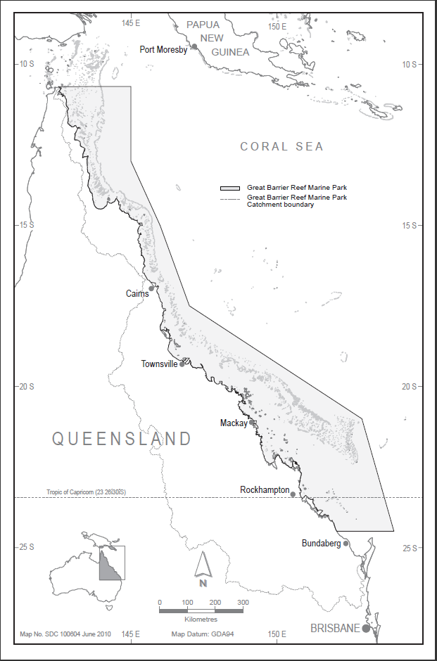
Figure 1: Great Barrier Reef catchment bo

