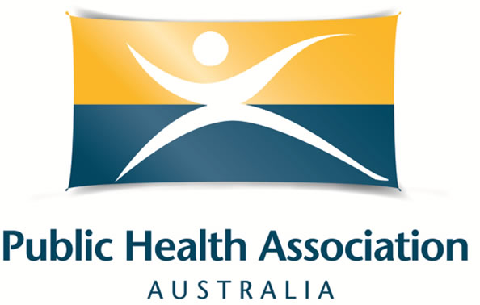
Scholarship Criteria and Application Form for the
Australian Public Health Conference 2020 (WA based applicants only)

With the aim of building the skills and capacity of our members, PHAA (WA Branch) is pleased to offer two (2) conference registration scholarships to attend the virtual Australian Public Health Conference 2020, from 19 October 2020. Applications are for one (1) student registration and one (1) standard registration.
Applications Close: COB Wednesday 19 August 2020

Applications received after this date will not be considered.
The total value of the scholarship is to cover the cost of the conference registration. PHAA will purchase the registration on your behalf. The scholarship offer applies to individual applicants only; organisations are ineligible.

Eligibility Criteria
Applicants must be:
- a current individual member of the Public Health Association Australia.
- living and working in Western Australia.
- able to demonstrate strong interest and commitment to public health.
- available to access the conference if their application is successful.
- have no access to financial support through your employment or a full scholarship to attend the conference.

How to apply
- Please complete the form provided in writing or by video, ensuring you answer all questions and send to phaawabranch@gmail.com by Wednesday 19 August 2020 close of business (COB).

Assessment of applications
- A selection panel from the PHAA WA Branch committee will assess all applications received. This will be a blind process.
- Applicants will be notified of the outcome by Wednesday 19 August 2020.

Scholarship conditions
- Successful applicants are asked to write a 500-word article or video to highlight the most interesting points of the Conference to be included in the Intouch in WA newsletter and to feature on the PHAA website. PHAA WA will provide assistance with writing if requested.
- PHAA will purchase registration on your behalf.

Additional information
- If you are successful as a student, you may be asked to provide evidence of full-time student status.
- The National Office will register you for the conference on your behalf and will send you an email confirmation once processed.
- For more details about the conference, please visit the conference website.

Selection process

- One (1) standard and one (1) student awardee will be decided based on:
- Anticipated benefits of attending the conference
- Contribution to public health through public health practice, voluntary work, community-based activities, research or PHAA committees or events

It is highly encouraged for applicants to have also submitted an abstract to the conference.

Preference will be given to applicants who have not previously been awarded a PHAA conference scholarship.

Application process
Please email a completed Application Form (see below) or a video (up to five minutes) to the PHAA WA Branch (phaawabranch@gmail.com) on or before COB Wednesday 19 August 2020. Please submit this as a Word document to allow for applications to be easily de-identified during the review process.

If you have questions on the application process, please contact us at the above email address.

Australian Public Health 2020 Conference Scholarship Application Form

Applicant details

Name
Length of PHAA membership (years)
Position
Organisation
Phone
Email
Standard registration OR Full-time student registration
Have you submitted an abstract for the conference?

Please tick to confirm the following statements to demonstrate your eligibility.
I am a resident of Western Australia.
I am currently an individual PHAA member.
I do not have access to financial support through employment or a scholarship to attend the conference.

*Maximum of 200 words per question

If you are unsure of any of the questions, please email phaawabranch@gmail.com for clarification

Please describe your current work and/or study experience in public health.

Please describe any other relevant experience in public health (i.e. volunteering, previous employment, etc.).

Please outline how your attendance at the PHAA Conference will benefit your studies and your future work.

Declaration by scholarship applicant
I declare that the information given on this application form is accurate and complete.

Name: ___________________ Date: ____________

