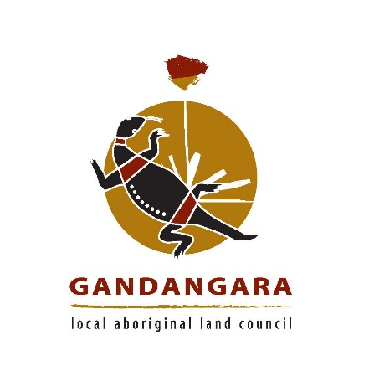
Chief Executive Officer

Gandangara Local Aboriginal Land Council (GLALC) is seeking applications from experienced and motivated people interested in a rewarding career as the Chief Executive Officer of the Gandangara LALC.
This position holder will provide an extensive range of assistance and support to the elected Board through the day-to-day management of Gandangara LALC’s affairs in accordance with delegated authorities; the provision of sound and accurate advice and the implementation of the Board’s resolutions in a timely and appropriate manner.
The successful applicant will need have tertiary qualifications in Business, Social Sciences or extensive relevant experience. In addition, the successful applicant will need to have extensive and demonstrated knowledge and understanding of the Aboriginal Land Rights Act, the capacity to interpret and implement legislation and sound communications skills. High level organisational and management experience is an essential requirement of this position together with an understanding of accounting practices and principles. A sound knowledge and appreciation of Aboriginal issues would also be required.
All applicants must obtain a copy of the recruitment package including the selection criteria for their application to be considered. To obtain a copy of the recruitment package please contact the Chairperson Tony Scholes by email at tscholes@glalc.org.au or on 0455 503 061.
Applications can be forwarded to Gandangara Local Aboriginal Land Council marked confidential and posted to:
The CEO Recruitment Panel
Gandangara Local Aboriginal Land Council
P.O. Box 1071
Liverpool BC NSW 1871

Applications Close Sunday 18th March 2018 @ 11.59pm

Being Aboriginal is a genuine occupational qualification for this position as described under Section 31 or Anti-Discrimination Act, 1977 (NSW)

