Senior Aboriginal Health Practitioner

Position details
Position Number: | 00020926 & 00020927
Classification: | AHP Level 2
Agreement: | Enrolled Nurses, Assistants in Nursing and Health Workers Agreement
Directorate: | Office of Chief Executive
Department: | Aboriginal Health
Location: | Perth Children's Hospital & Perth CBD

Reporting relationships

This position reports to:
00008744 | Director Aboriginal Health |  |  | Level 10

Positions under direct supervision:

Nil

Key Responsibility
- To work with health care teams to provide culturally safe, holistic person-centred clinical care, health education and promotion for Aboriginal and non-Aboriginal people within Western Australia as specified in the summary of duties including working within their scope of practice and considerate of the Aboriginal and Torres Strait Islander Health Practice Board of Australia professional capabilities.

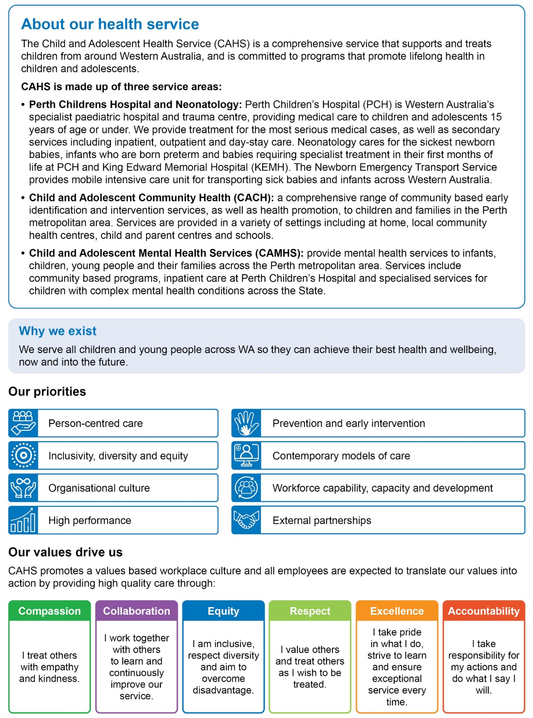

Summary of accountabilities
1. Leadership
- Provides cultural safety to patients and their families.
- Support a culturally respectful and non-discriminatory journey for patients and their families to ensure health equity
- Provides a cultural model of care with a holistic focus that incorporates a patient and family centred approach.
- Advocate, support and respect patients and their families to maintain their cultural and social obligations where practical.
- Applies a cultural lens to support health literacy to increase knowledge of procedures and treatments and ensure patients and families make informed decisions on health care.
- Ensure cross cultural misunderstandings are identified and addressed.
- Supports cultural navigation of health system.
- Understands the importance of culture in being central to treatment and applies this to assist better health outcomes.
- Provides support and advice to other health professionals on cultural safety.
- Acts as a trusted cultural advisor for clinical teams.
- Positive role model for students and team members.
2. Clinical
- As part of the Health Care Team conducts health assessments, screening, monitoring, and treatment of patients and documentation within their scope of practice and within a health service, outpatient clinic, community, or home setting and under the supervision of a suitably qualified health practitioner/clinical supervisor.
- Collaborates with the health care team to develop, implement, and review community and health services-based health strategies and programs.
- Develops effective working relationships/partnerships with local primary health care providers and health services.
- Identify indicators for Aboriginal health and well-being and initiate appropriate responses and reforms.
- Safely administers medications and/or vaccinations as prescribed by a qualified health practitioner ensuring adherence to the 6 rights of medicine administration.
- Provides supervision and mentorship for Aboriginal Health Practitioner students & newly qualified Aboriginal Health Practitioners and/or workers.
3. Health Education and Promotion
- Works with the health care team to identify and develop strategies to address health care needs within local Aboriginal communities
- Senior Aboriginal Health Practitioner | Level 2 | 00020926 & 00020927
- Uses all opportunities to engage and encourage Aboriginal people and their families to be responsible for their own health and wellbeing.
- Liaises with other stakeholders/service providers to provide culturally safe and appropriate health education and health promotion activities with relevance to local community priorities.
4. CAHS governance, integrity, safety and quality requirements
- Commits to undertake the duties of the role in accordance with the WA Health Code of Conduct; the CAHS Vision and Values; and CAHS commitment to protecting children and promoting their safety.
- Maintains a safe work environment by taking reasonable care for own health and safety and that of others.
- Undertakes duties to an agreed performance standard to support safe, high-quality health care with a focus on continual improvement, efficiency, effectiveness and sustainability.
- Directly or indirectly supports the delivery of safe patient care and the consumers’ experience ensuring services are family centred.
- Supports the delivery of safe patient care and the consumers’ experience including participation in continuous quality improvement processes in accordance with the requirements of the WA Healthcare Safety and Quality Capabilities Framework, the NSQHS standards and other recognised health standards
- Completes mandatory and core requirement training as relevant to the role and service.
- Performs duties in accordance with WA Public Sector, WA Health, CAHS and other specific service policies and procedures and applicable legislative obligations under Public Sector Management Act (WA) 1994, Health Services Act (WA) 2016, Work Health and Safety Act (WA) 2020, Disability Services Act (WA) 1993 and the Equal Opportunity Act (WA) 1984.
- Actively contributes to the development of the health service by undertaking other duties as directed including additional tasks or projects in line with continual improvement, collaboration and sustainable health initiatives.
Other duties
- Initiates quality improvement activities within the health care team.
- Undertakes continuing education of self and updates own knowledge and skills through approved professional development activities and/or certifications/qualifications. This includes all mandatory training and ongoing registration requirements relevant to the role.

Work related requirements
The following criteria should be considered in the context of the CAHS Vision, Objectives and Values.
Essential selection criteria
- Identify as Aboriginal and/or Torres Strait Islander.
- Registered with the Aboriginal and Torres Strait Island Health Practice Board of Australia and have a minimum of 5 years’ experience as an Aboriginal Health Practitioner.
- Demonstrated ability and/or experience in working with Aboriginal people to provide primary health care in a hospital, outpatient, community, or home settings.
- Well-developed verbal and written communication skills.
- Demonstrated effective interpersonal and negotiation skills.
- Demonstrated ability to effectively engage with all levels of health care providers.
- Demonstrated ability to work independently and/or as a member of the multidisciplinary health care team.
Desirable selection criteria
- Additional qualification in a clinical specialty area.
- Demonstrated knowledge of the principles of primary health care with relevance to Aboriginal health.
- Demonstrated ability to use computer systems including email, word processing and data entry for information collection and confirmation.
- Current knowledge and commitment to Equal Opportunity and Work Health and Safety in all aspects of employment and service delivery.
Appointment to this position is subject to the following:
- Aboriginality is a genuine occupational requirement and is authorised under Section 50d of the Equal Opportunity Act 1984.
- Successful 100 Point Identification Check.
- Working with Children (WWC) Check, compulsory check for people who carry out child-related work in Western Australia.
- Provision of the minimum identity proofing requirements in line with the standards set by the National Security Strategy.
- Successful criminal record screening clearance.
- Successful pre-employment integrity check.
- Successful pre-employment health assessment.

Certification
Created on | Last Reviewed | Registered
3/07/2023 | 24/06/2025 | 24/06/2025
I verify that the details in this document are an accurate reflection of the requirements of the position.
Manager / Supervisor |  | Signature or HE Number |  | Date
As an Occupant of this position, I have noted the statement of duties, responsibilities and other requirements as detailed in this document.
Occupant Name |  | Signature or HE Number |  | Date

