
Justice Health & Forensic Mental Health Network
Aboriginal Chronic Care Program
The program is operational in sixteen (16) correctional facilities (15 adult and 1 juvenile) state wide.
The Aboriginal Chronic Care Program, (ACCP), relates directly to strategic directions of the NSW State Health Plan Towards 2015, specifically relating to the expansion of programs for Aboriginal people to prevent and reduce the impact of chronic disease through a focus on the common risk factors and to promote healthy lifestyles.

Aboriginal Chronic Care Program sites in NSW
- Tamworth Correctional Centre
- Wellington Correctional Centre
- Silverwater Women’s Correctional Centre
- Cessnock Correctional l Centre, Maximum
- Cessnock Correctional Centre, Minimum
- Lithgow Correctional Centre
- Mid North Coast Correctional Centre
- John Morony Correctional Centre’s
- Dillwynia Correctional Centre
- Broken Hill Correctional Centre
- Ivanhoe Correctional Centre
- Glen Innes Correctional Centre
- Emu Plains Correctional Centre
- Frank Baxter Juvenile Detention Centre
- South Coast Correctional Centre

Aim
To 'Close the Gap' in chronic conditions for Aboriginal and Torres Strait Islander peoples who come into contact with the criminal justice system in NSW.

Interventions
- Systematic screening for a chronic condition
- Include the Chronic Disease Screening assessment and the Ministry of Health Spread sheet
- Referral to Care Navigation Support Program for follow up, whilst in custody
- Health education
- Health promotion, especially related to tobacco control
- Strategies for chronic condition self management
The Aboriginal Chronic Care Program is a comprehensive approach to addressing the chronic conditions of our Aboriginal patients, with a focus on the whole person rather than having a single disease or 'body part' approach to health care programs and service delivery.
The current rate of Aboriginal patients within NSW Correctional Centres is 24%.
- The age specific imprisonment rates for Aboriginal people are predominantly 20 – 45 years of age, therefore, younger Aboriginal people are being screened for and identified with chronic conditions that are both treatable and manageable.

Key Performance Indicators
The NSW Health Ministry, in partnership with Justice Health & Forensic Mental Health Network, have set Key Performance Indicators and these are reported on, monthly:
- Spirometry
- Hypertension
- HbA1c Screening
- Urine Screening
- Renal Disease
- Number of Aboriginal patients accessing the program
- Number of Chronic Conditions identified
- Number of referrals to Care Navigation Support Team
Recourses
- The ACCP Nurse gives a water bottle, to each patient who agrees to have the assessment
- We also have 2 lots of stickers, (to be used by the nurse or Aboriginal Health Worker). These are used in and on the front of the patient’s file.
- Our shared drive pathway is: G/shared/Aboriginal Chronic Care Program. From here we place all the required stats for the MOH. The ACCP Coordinator, collates this information, along with the Justice Health stats, each month.
- The Aboriginal Delegate is very useful with helping to support the patients coming to the clinic for the program.
- The Nominal roll, will give you the names of patients that need to be seen, ie we try to start with the patients over the age of 35 years. If these are completed, we can then screen the others as well. We just want to make sure that the ones that may be at greatest risk, are able to be screened first.
Hours
- There is funding for the ACCP sites to have a minimum of 8 hours/fortnight.
- If your site has capacity to manage extra hours, just contact the coordinator for approval.
- If the ACCP clinic does not go ahead, contact the Coordinator and let her know the reason why. THIS IS IMPORTANT.
- If possible notify the coordinator of the ACCP dates as soon as you have your roster.
- If your site has an Aboriginal Health Worker, they will be able to work with you on the day.
- All stats have to be on the shared drive as soon as the ACCP clinic if completed. This will prevent being chased up at a later date.
- Please make sure that the Nurse Unit Manager has allocated a minimum of 2 days/month for ACCP on the roster.
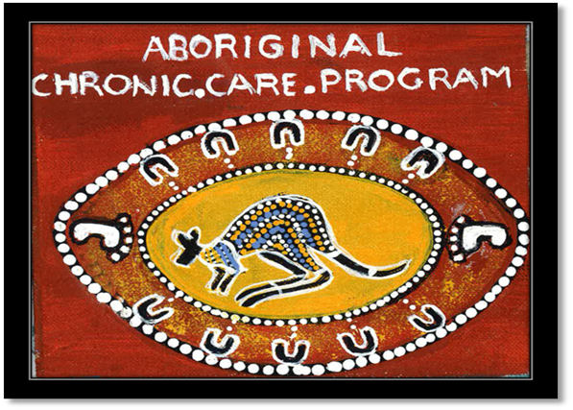
Libby Johns
Aboriginal Chronic Care Coordinator
0409828542

