National eye care equipment inventory project
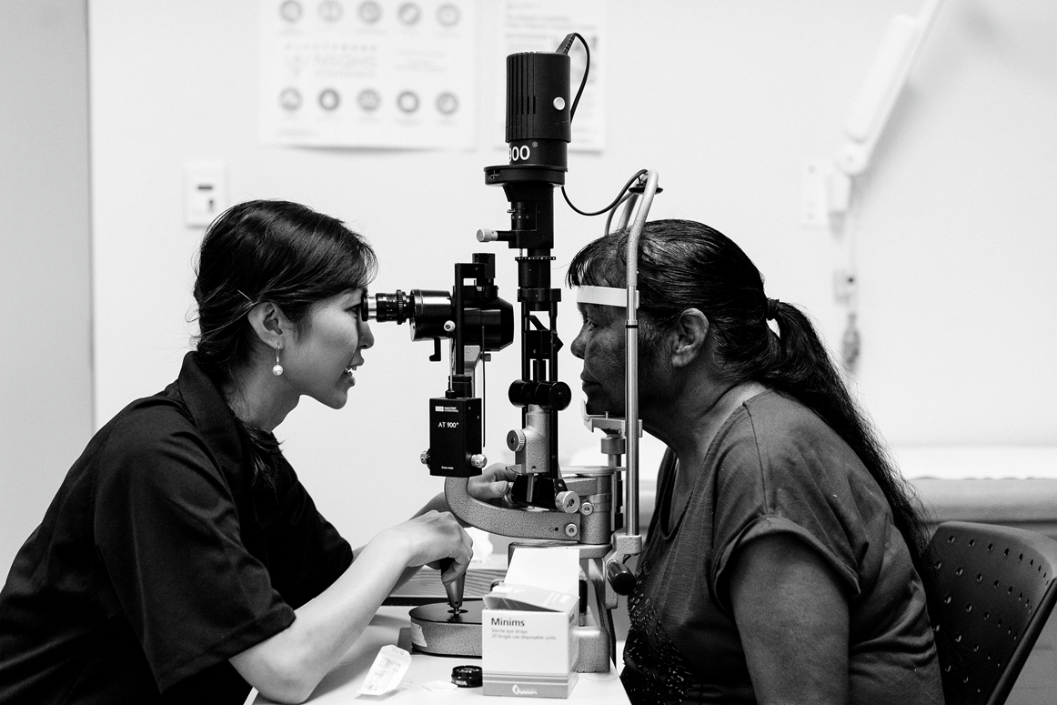
Ophthalmology Assessment Tool
Information on the eye care equipment needs required to deliver comprehensive eye health programs to Aboriginal and Torres Strait Islander communities is essential to close the gap in eye health. Without information to guide us, eye health services may be missing vital equipment used to screen, diagnose and treat eye conditions. It is for this reason that The Fred Hollows Foundation has been commissioned by the Australian Government Department of Health to undertake a National Eye Care Equipment Inventory Project. Phase 1 of this project was undertaken from June 2016 – 2017 and focused on Primary Health Care facilities which are providing eye care services to Aboriginal and Torres Strait Islander communities/peoples. This phase provided detailed information on eye care equipment distribution and deficits within the Primary Health Care sector across the country.
Phase 2 of the NECEIP will build on this information and focus on both the Ophthalmology services supported by the Rural Health Outreach Fund (RHOF), and Optometry services supported by the Visiting Optometrists Scheme (VOS), to catalogue existing equipment and identify additional equipment needs. This form is specifically for those services delivered with the support of the Rural Health Outreach Fund (RHOF). This information will be used to inform future eye health service planning and investment specifically targeting Aboriginal and Torres Strait Islander peoples.
Your service has been invited to participate in this project because of your involvement in the delivery of eye care services to Aboriginal and Torres Strait Islander people. We request that this form is completed by the appropriate staff member and returned to The Fred Hollows Foundation via email (inventory@hollows.org).
NOTE: Where you provide services across more than one state or territory please complete a separate assessment tool for each jurisdiction.
Data Disclaimer: The Fred Hollows Foundation has been commissioned by the Australian Government to establish a National Eye Care Equipment Inventory to support the identification of eye health testing equipment and training needs across Australia. The data collected by The Fred Hollows Foundation for the purposes of this project relates to existing eye care equipment and eye care services provided by your service. This data is owned by the Australian Government and will only be used for the purposes outlined in this project (establish eye health equipment needs). No client data will be collected during this project.

THANK YOU FOR PARTICIPATING IN THIS PROJECT

National Eye Care Equipment Inventory Project

Contact Information
Eye Practitioners name, Company and address: |  | Please indicate which jurisdiction you provide services to Aboriginal and Torres Strait Islander peoples in:  QLD NT  NSW TAS  VIC ACT  WA SA
We are a RHOF provider:  Yes No | Phone:
We are a RHOF provider:  Yes No | Fax:
Report prepared by: | Date report prepared:

Service information
Please provide a list of the locations where you provide eye care services (or attach list):
Town/Location | Facility Name | Contact details (including address) | ACCHO  Yes / No | RHOF  Yes / No

Equipment Inventory - Portable
Please list the portable eye care equipment that you take to each location:
Equipment | Yes / No | Model
OCT

Laser

IOL Master and A-scan biometry

Visual Fields Machine

Operating Microscope

Tonometer

Slit Lamp

VA Chart

Retinal Camera

Others: please specify

Equipment Inventory – Fixed
Please list the fixed eye care equipment used in each location:
Equipment | Yes / No | Model | Is facility an ACCHO? Yes / No
OCT

Laser

IOL Master and A-scan biometry

Visual Fields

Operating Microscope

Tonometer

Slit Lamp

VA Chart

Retinal Camera

Others: please specify

Equipment Requirements
Please identify the eye care equipment that you do not currently have that you deem necessary to provide comprehensive eye care and any information to support this request if required:
Eye care equipment required: | Yes / No | Please provide information on where the equipment will be located and a brief description of the need:
OCT

Laser

IOL Master and A-scan Biometry

Visual Fields

Microscope

Tonometer, Slit Lamp, VA Chart

Retinal Camera

Others: please specify


Thank you
Contact details
Lisa Penrose – Project Consultant
Phone: 0481 267 015
Email: lisa@penroseoptometry.com.au

Alison Rogers – Assistant Manager
Programs
Phone: (08) 89 201 423
Email: arogers@hollows.org

