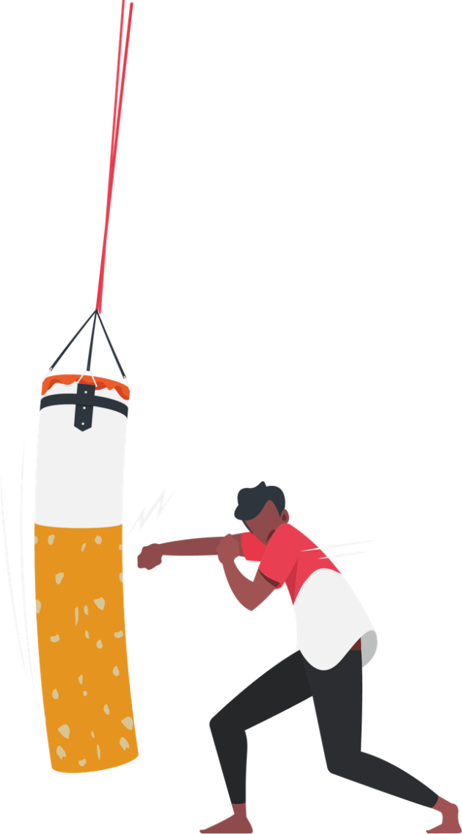
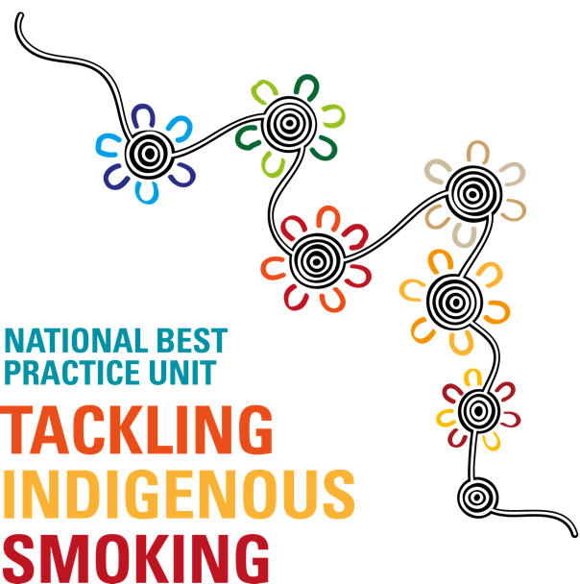
Smoke-free Policy
Organisation Name

This Smoke-free Policy Template outlines <ORGANISATION NAME>’s business commitments to creating and maintaining a smoke-free workplace.
Smoking greatly increases the risk of developing a range of cancers, heart disease and respiratory illness. Second- and third-hand smoke (passive smoking) is also a risk to health, and people who do not smoke should be protected from these environmental hazards. Evidence also shows that smoke-free workplaces are more supportive for people who are trying to quit.
Legislation and the legal duty of care also provide clear reasons for having a smoke-free workplace:
- occupational health and safety laws require employers protect their staff and any workplace visitors from avoidable health risks such as those posed by passive smoking;
- all states and territories have laws banning smoking in indoor environments including office buildings, shopping malls, schools and cinemas;
- passive smoking may be a health risk in outdoor areas as well as in enclosed indoor spaces. Each state and territory has a different approach for managing smoking in outdoor areas.
More information about your state or territory legislation can be found here.
Implementing a smoke-free workplace policy sends a strong message to all staff and visitors that our workplace is committed to providing a healthy, supportive working environment.
Timing: This policy is effective from <ENTER START DATE >.
Who is affected by the policy: This policy applies to all staff, visitors and contracted services of <ORGANISATION NAME> while on company premises.
Our Mission: <ORGANISATION NAME> is committed to:
- making our place a smoke-free work space;
- supporting workers who want to quit smoking;
- protecting workers and visitors from second- and third-hand smoke;
- making workers aware of the health risks associated with smoking and the benefits of being smoke-free.
Strategies to achieve this:
- Smoke-free areas
<ORGANISATION NAME> requires the following areas of the workplace to be smoke-free at all times:
- all indoor areas
- all covered areas
- all outdoor areas except for the following designated area: <NAME AND LOCATION OF SMOKING AREA>
- company vehicles
- all vehicles within the workplace grounds.
[WHERE THE WORKPLACE HAS AUTHORITY TO PUT UP SIGNS]
Signs at the entrance and within the workplace will display the smoke-free status of our workplace. The smoking area will also be clearly signed.
- Position on smoking breaks
Smoking by staff members on <ORGANISATION NAME> grounds is only permitted during designated breaks, either within the designated smoking area <NAME AND LOCATION OF SMOKING AREA> or outside of <ORGANISATION NAME> grounds. Refer to ‘Expectations of staff’ for managing breaches of this policy.
- Position on smoking in uniform
Smoking in uniform is not permitted. Staff members wishing to smoke during breaks will need to change out of or cover up their uniform first. This includes while on work-related activities or travel outside of the workplace. Refer to ‘Expectations of staff’ for managing breaches of this policy.
- Position on electronic cigarettes
Electronic devices such as e-cigarettes (also known as vapes) may be harmful to users and to other people exposed to second-hand vapour. This policy therefore also applies to all e-cigarette use. E-cigarettes are not permitted to be used in any of the smoke-free areas referred to in this policy. Refer to ‘Expectations of staff’ for managing breaches of this policy.
- Supporting staff members who smoke
<ORGANISATION NAME> will provide support to help staff members who smoke adjust to the changes. <ORGANISATION NAME> will also provide support to any staff member wishing to quit smoking. This includes:
- promoting the Aboriginal Quitline on 13 78 48, for example through email reminders, company newsletters and workplace posters;
- making health information available, for example through engaging the local Tackling Indigenous Smoking (TIS) team to provide education sessions, or sharing information on the benefits of being smoke-free via health promotion posters or pamphlets;
- providing access to quit smoking programs and other resources such ‘Keep our place a smoke-free space’ branded car fresheners, fidget spinners or stress balls;
- celebrating staff smoke-free successes.

Roles and Responsibilities:
- Expectations of Staff
[A CLEAR STATEMENT IS REQUIRED ON WHAT THE CONSEQUENCES ARE IF A STAFF MEMBER IS NON-COMPLIANT WITH THE POLICY. EXAMPLES ARE PROVIDED BELOW, BUT IT IS UP TO THE ORGANISATION TO DECIDE WHAT IS FEASIBLE AND APPROPRIATE. EXAMPLES OF POSSIBLE STATEMENTS INCLUDE:
- This smoke-free policy is an integral part of our existing workplace health and safety policies.
- Staff are expected to understand and comply with this policy at all times while in the workplace or representing <ORGANISATION NAME>
- Staff should also ensure their visitors are aware of the policy.
- Staff should inform management if they believe the policy has not been upheld.
- Complying with this policy is a condition of employment at <ORGANISATION NAME>.
- The responsibility for enforcing the policy rests with all managers, supervisors and staff.
- Any breach of this policy will lead to the normal disciplinary procedures being applied <DESCRIBE WORKPLACE DISCIPLINARY PROCEDURES>.
- Any worker who has a grievance relating to this policy should speak to the Health and Safety Officer or appropriate representative.
- Employees cannot be disciplined for smoking away from the workplace, out of uniform, in their own time.]
- Expectations of visitors
Visitors are expected to comply with this smoke-free policy. The following five-step non-compliance strategy will be followed if anyone breaches <ORGANISATION NAME>’s smoke-free policy:
- Assume that the person is unaware of the smoke-free policy.
- A staff member or security staff will approach the person breaching the policy, remind them about the smoke-free policy and politely ask them to refrain from smoking (or direct them to a designated smoking area if one has been established).
- If the person continues smoking in a smoke-free area, they must be made aware that if they don’t stop smoking they will be required to leave the premises.
- If the person continues smoking in the smoke-free area, they will be escorted off the premises by staff and/or a security officer.
- Under no circumstances should <ORGANISATION NAME>’s smoke-free policy be breached.
- Expectations of management:
- The policy - and any amendment - is clearly communicated to all staff and prospective staff. This includes during the recruitment and induction processes;
- The policy is accessible to all members of the organisation;
- Ensuring anyone else associated with the organisation (including contractors and board members) or visiting the premises are aware that <ORGANISATION NAME> is smoke-free and comply with the policy.

Review
This policy will be reviewed six months after implementation, then annually. [INSERT COMMITTEE/DESIGNATION/ROLE] is responsible for reviewing this policy to maintain currency. This process should include:
- ensuring that the policy remains in line with relevant legislation;
- seeking feedback from staff and implementing any appropriate suggestions for change;
- assessing policy impact and introducing any actions needed to improve the effectiveness of the policy (e.g. education sessions with staff).

General Manager/HR | CEO:
Signature: | Signature:
Date: | Date:
Date of next review:

